ASI ANYWARE SHOPPING CART APP

This application will run on any mobile device over the internet, however, a bigger screen such as an IPAD or mini tablet is recommended. ASI Anyware requires the Progress App Server web software, which provides a secure seamless integration to Advantzware orders. In addition, ASI Anyware allows customers to create releases against orders as well as inquiry into current and past orders, invoices and inventory.

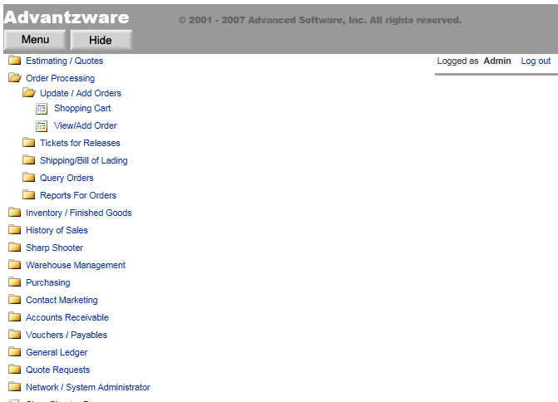

ASI ANYWARE ORDER ENTRY - SHOPPING CART APP

Orders can be added from an estimate, from a quote or from inventory via the shopping cart application. Login user ID’s are assigned to customers and internal sales representatives. The user ID is assigned specific customer accounts. In this example, the user IBM logged in an only data for the customer IBM1000 will be available via the application. Internal sales people will have multiple customers to select, therefore they will use the Book Icon to search for a customer. Once the customer code is selected, standard order information is displayed as payment type, carrier, payment terms and purchase order number.

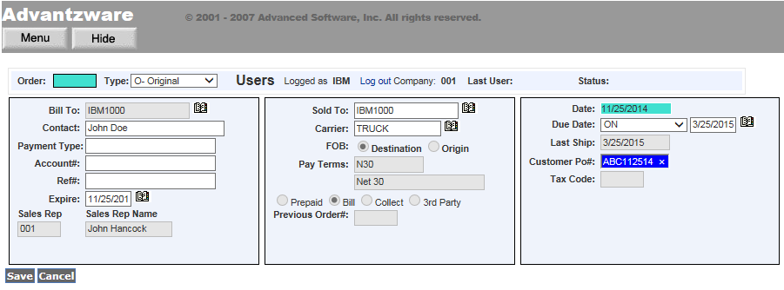

Finished Goods items are added to the order by searching for an existing quote then selecting a quoted quantity. For stocked items, the quote can be bypassed and the finished goods item added and followed by the quantity. The items customer part number, items description, sell price and unit counts immediately transfer to the screen. Additional data such as due date, over and under percentages can be updated prior to saving the line item.

